# COMP 3610

**Data Information Knowledge Wisdom**

**In-class Exercise**

**Purpose:**

To review the terms introduced in lecture 1: data, metadata, information, date, format, date standard(s), knowledge. To compare date formats. To introduce data models (chapter 2) and conceptual modeling (chapter 1 & 2)

Please study the image below and identify the following:

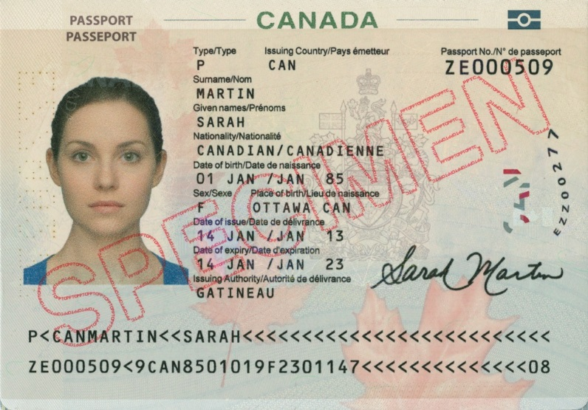

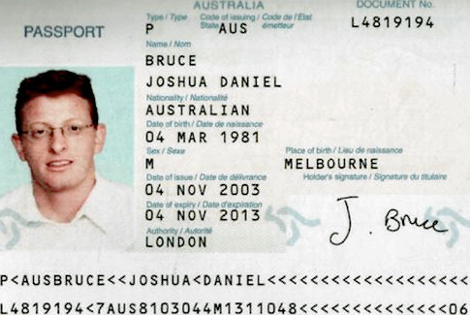

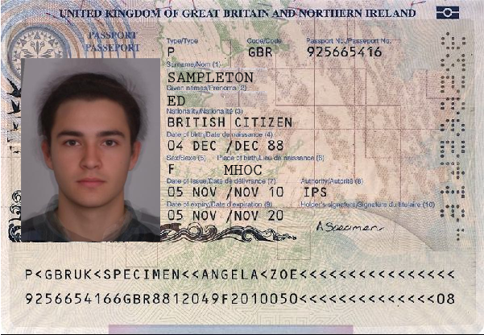

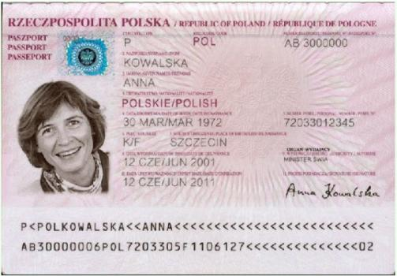

* examples of data, metadata, information, knowledge, wisdom (?).
* What are the date formats? What are the standards? What is the International Organization for Standardization **ISO 8601** standard for date representation and format? Compare/discuss the readability of the formats.
* Design a conceptual model to represent the data (one entity and many attributes)

**Note:**ISO 8601 describes an internationally accepted way to represent dates and times using numbers. <https://en.wikipedia.org/wiki/ISO_8601> <http://www.iso.org/iso/home/standards/iso8601.htm> .